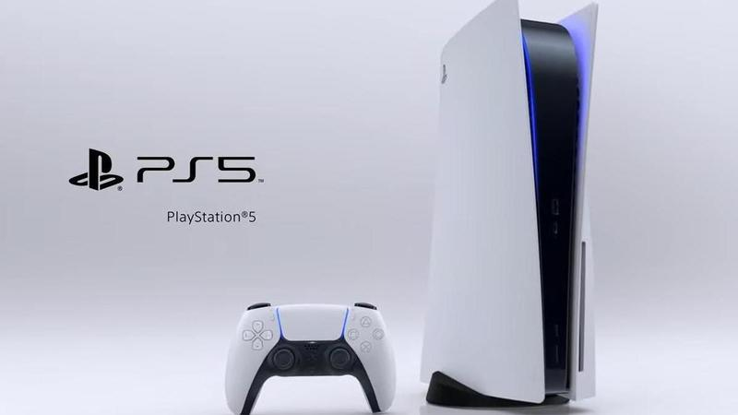

**PlayStation 5**

**Price: $499**

**Description:**  The PlayStation 5 (PS5) is a home video game console developed by Sony Interactive Entertainment. Announced in 2019 as the successor to the PlayStation 4, the PS5 was released on November 12, 2020, in Australia, Japan, New Zealand, Singapore, North America, and South Korea, with worldwide release following a week later. The PS5 is part of the ninth generation of video game consoles, along with Microsoft's Xbox Series X and Series S consoles, which were released in the same month.

**System Specifications:**

* CPU: x86-64-AMD Ryzen Zen 8 Cores / 16 Threads at 3.5GHz (variable frequency)
* GPU: Ray Tracing Acceleration Up to 2.23 GHz (10.3 TFLOPS)
* MEMORY(RAM): 16GB GDDR6/256-bit
* STORAGE: NV Me SSD Slot / USB HDD Support

**Developed By:**

